URL: <http://www.nsc.gov.sg/>

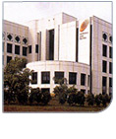The National Skin Centre (NSC) is an outpatient specialist dermatological centre with a team of dermatologists who have the experience and expertise to treat every skin condition. NSC started its operations on 1 November 1988 after taking over the treatment of skin diseases from Middle Road Hospital. We handle a patient load of about 1,000 patients daily. We are a government restructured institution and a subsidiary of the National Healthcare Group Pte Ltd (NHG), sharing the NHG vision of "**Adding years of healthy life to the people of Singapore**".

As a tertiary health care institution, the NSC provides specialized dermatological services, train medical students and post graduates, and undertakes research in dermatology.

We conduct Continuing Medical Education for doctors and paramedical personnel. Our researches ensure that patient management is best tailored to local population.

**Mission of NSC**  
Our mission is to be the national and regional centre of excellence for the diagnosis and treatment of skin diseases.

We are committed to provide cost-effective and specialised care of skin conditions in a setting of clinically relevant research, quality education and patient safety.

**NSC Objective**  
The Centre's objectives are to concentrate specialists in dermatology into one institution, facilitate subspecialization and be the national focus for the treatment, research, and training on all aspects of skin diseases.

Services:

General Clinic

## Nursing Services

## Pharmacy Services

Laboratory Services:

**MycologyDermatopathology**  
**Immunofluorescence**  
**Enzyme-linked**

**Immunosorbent**

**Assay**

**(ELISA)**

**Immunohistochemistry**   
**Molecular**

**Diagnostics**.

**Clinical**

**Laboratory**

**Services**  
**Immunology**

**Laboratory Mycology**

**Laboratory**

**Services**  
**Dermato-Pathology Laboratory**

## Department of STI Control (DSC)

## Mandalay Clinic Laser (MAC) & Procedures

MedliteC6™LaserTreatment   
  
MiXtoSXCO2FractionalLaserTreatment   
  
FillerInjectionSculptra(Poly-L-lacticacid)   
Botulinum Toxin

|  |
| --- |
|  |

## Procedure Suites and Skin Surgeries

**Biopsy**

**shave**   
**Curettage**   
**Incisionanddrainage**   
**Skingraftingandflap**   
**SurgicalExcision**

|  |
| --- |
|  |

**Electrosurgery**

**Mohs Micrographic Surgery for Skin Cancers Micrographic (Mohs’) surgery**

 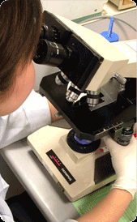 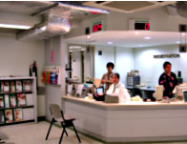

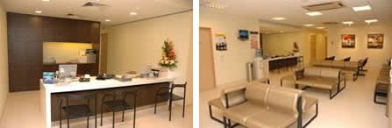

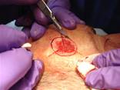

**Doctors credentials:**

**MEDICAL DIRECTOR/SENIOR CONSULTANT**

**Adjunct Prof CHAN Roy**   
MBBS, MRCP (UK), FRCP (Lond), Dip. Derm (Lond), Dip. Ven (Lond), FAMS

**Senior consultants**

Dr CHUA Sze Hon  
MBBS, MRCP (UK), FRCP (Edin), FAMS   
*(Clinical Interests: Dermatological & Laser Surgery, Immunodermatology)*  
  
Clinical Assoc Prof GIAM Yoke Chin  
MBBS, M.Med (Paed), FAMS   
*(Clinical Interests: Dermatopathology, Paediatric Dermatology, Skin Health)*  
  
Clinical Prof GOH Chee Leok   
MD, MBBS, M.Med (Int. Med), MRCP (UK), FRCP (Edin), FAMS   
*(Clinical Interests: Contact & Occupational Dermatitis, Dermatological & Laser Surgery)*  
  
Dr GOON Teik Jin Anthony   
MBBS, MRCP (UK), FAMS  
*(Clinical Interest: Contact & Occupational Dermatitis)*

Dr LEOW Yung Hian  
MBBS, M.Med (Int. Med), FAMS   
*(Clinical Interests: Contact & Occupational Dermatitis, Drug Eruptions)*

Dr NG See Ket   
MBBS, M.Med (Int. Med)   
*(Clinical Interest: Contact & Occupational Dermatitis)*   
  
Dr SEOW Chew Swee  
MBBS (Malaya), M.Med (Int. Med)   
*(Clinical Interests: Cutaneous Infections)*

Dr TAN Hiok Hee  
MBBS, MRCP (UK), FRCP (Edin), FAMS  
*(Clinical Interests: Cutaneous Infections, Sexually Transmitted Infections & HIV)*   
  
Clinical Assoc Prof TAN Suat Hoon  
MBBS, M.Med (Int. Med), Dip. RC Path (DMT), FAMS   
*(Clinical Interests: Cutaneous Lymphomas, Dermatopathology, Immunodermatology)*

**Associate consultants**

Dr CHIAM Yuun Tirng Lynn  
MBBS, MRCP (UK)

Dr KWAH Yung Chien Raymond  
MBBS, MRCP (UK)

Dr LIM Kar Seng  
MBBS, MRCP (UK)

Dr LIM Yen Loo  
MBBS, MRCP (UK)

Dr TAN Wee Ping  
MBBS, MRCP (UK)

**Contact us: National Skin Centre(S) Pte Ltd**  
      1 Mandalay Road Singapore 308205

      Tel: (65) 6253 4455        Fax: (65) 6253 3225 